**List:**

Sort Z-A:  
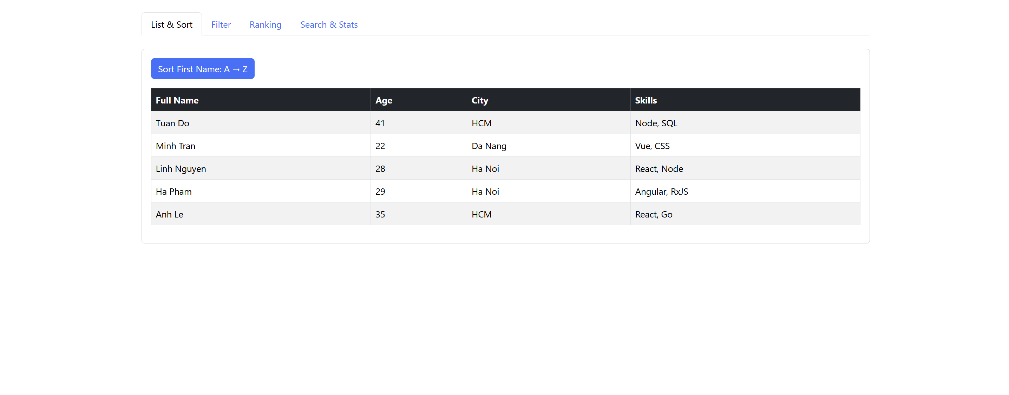  
Sort A-Z:  
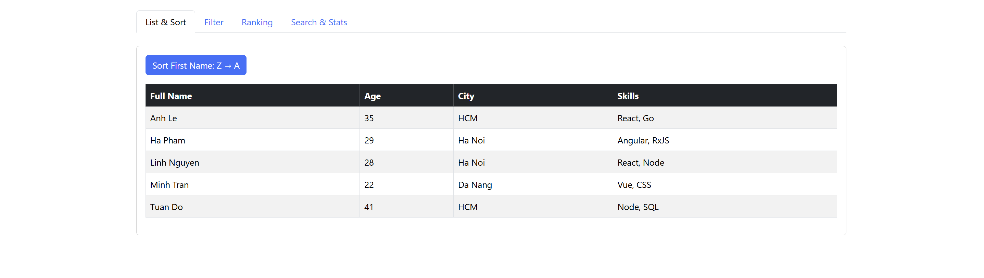

**Filter:**

Age:  
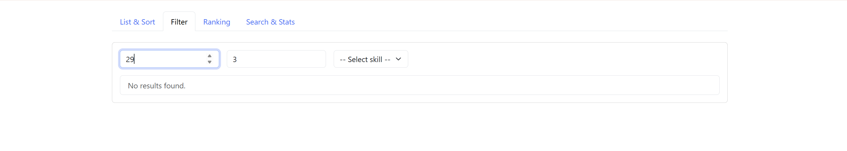

Skill:  
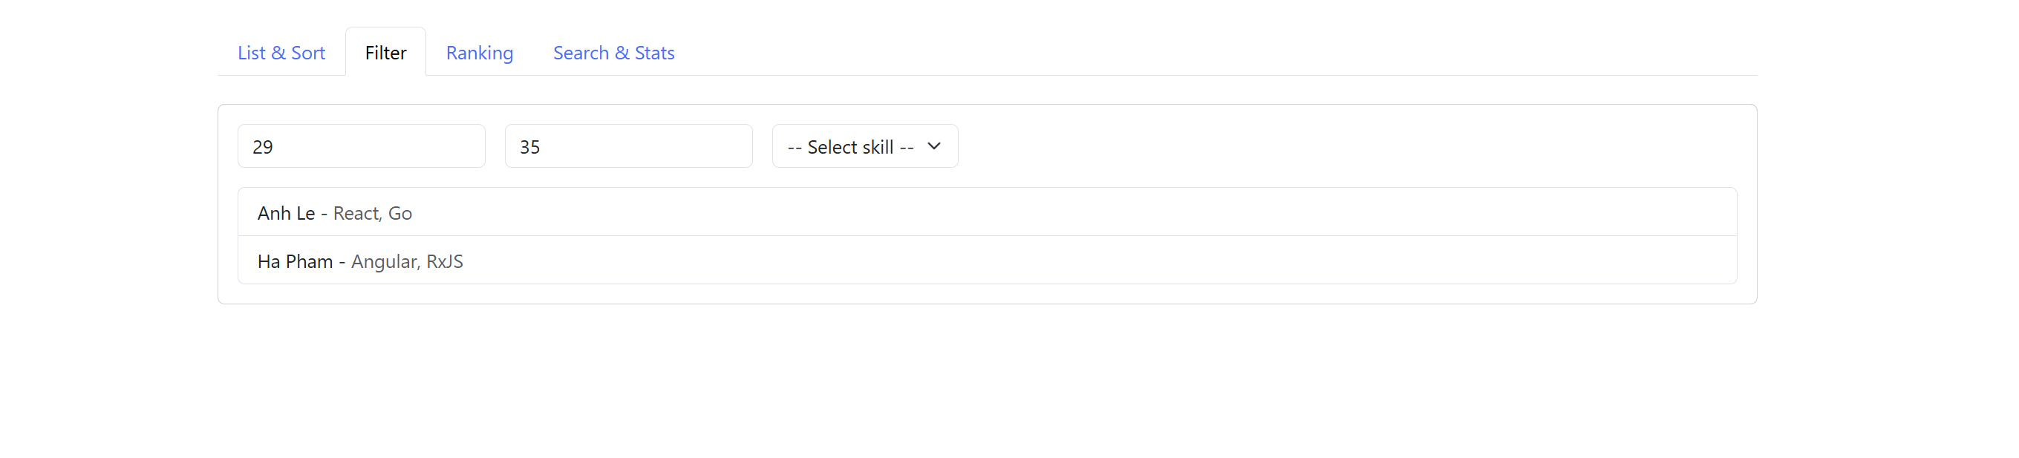

Skill:

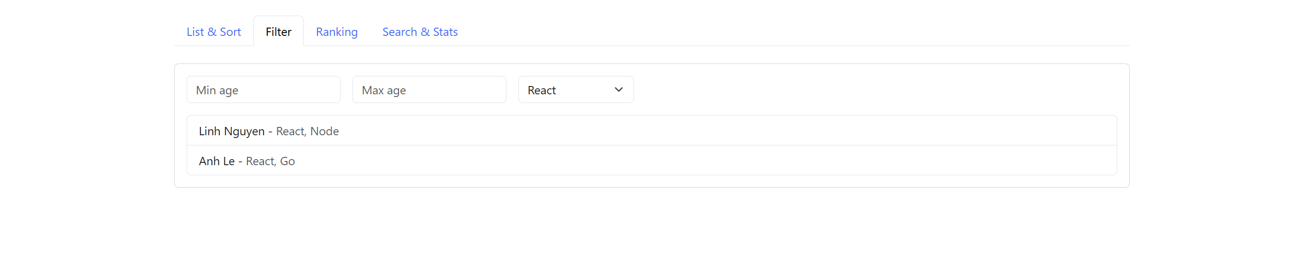

**Ranking:**

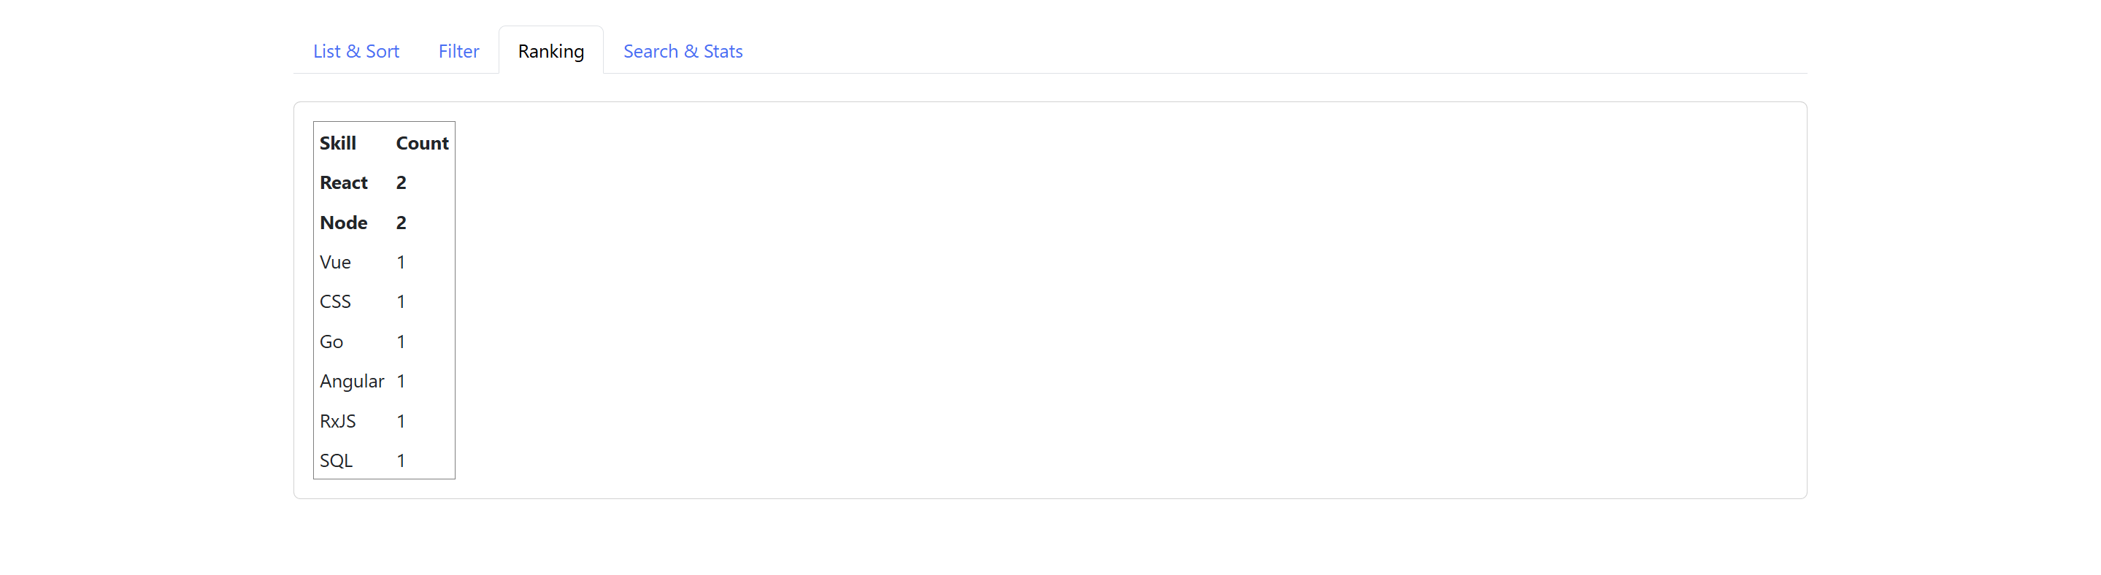

**Search and Stats:  
